**Your brain**

**2.1) Find perimeter difference of earth and circle around it in same units as provided in the example.**

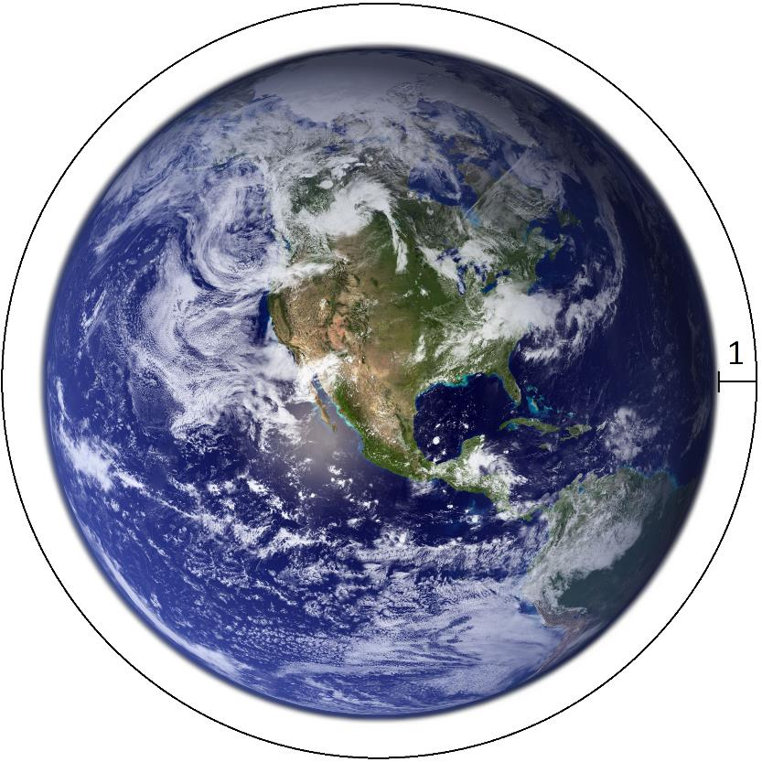

PCIRCLE − PEARTH = X;

P = 2 π r

2 π rCIRCLE - 2 π rEARTH = X

*rCIRCLE -rEARTH= 1*

*r CIRCLE = rEARTH+1*

2 π (*rEARTH+1)* - 2 π *rEARTH* = X

*rEARTH+1 - rEARTH = X/2* π

*~~r~~~~EARTH~~ ~~– r~~~~EARTH~~ + 1 =X/2* π

X/*2* π = 1

X = *2* π

I hope this is how math works

**2.2) In a survey of 75 software engineers it was found that 46 use open source and 40**

**use web technologies. Twenty of the software engineers who use open source also**

**use web technologies. Draw Venn diagram for given information.**

Total engineers: 75

open source only: 26

web technologies only: 20

both options: 20

no answer: 9

2 versions:

First version is more aesthetically pleasing, but the scale is off- the two bubbles for open source and web technology can’t fit in the “total number of engineers” bubble :(

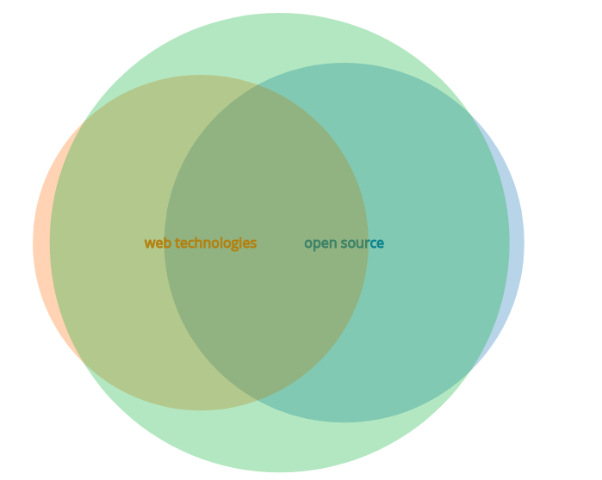

2nd version is correct, but it’s ugly :(

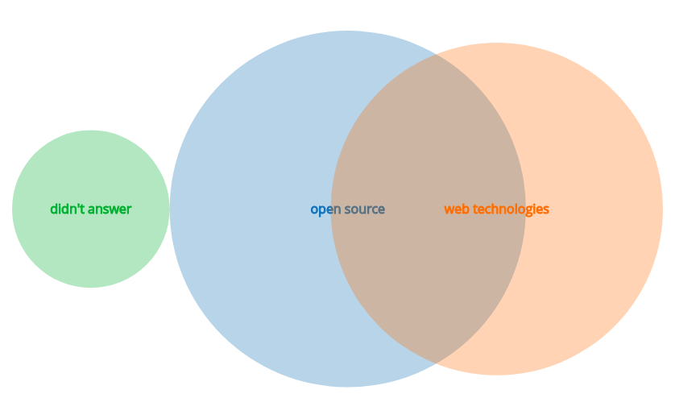

**2.3) There are 5 people (Ana, Bob, Charlie, Diana and Ebbe) working with 5 different**

**programming languages distributed through 5 floor building. Each person use a**

**unique language and works in different floor. Please fill in table below from**

**conditions:**

* Bob is working with JavaScript;
* Python developer is one floor beneath SQL developer;
* Bob works 3 floors beneath Diana;
* C# developer works on second floor;
* Java developer is 3 floors above Ana;
* Ebbe does not know Python programming language .

|  |  |  |  |  |  |
| --- | --- | --- | --- | --- | --- |
|  | Ana | Bob | Charlie | Diana | Ebbe |
| Language | C# | JavaScript | Python | SQL | Java |
| Floor | 2 | 1 | 3 | 4 | 5 |